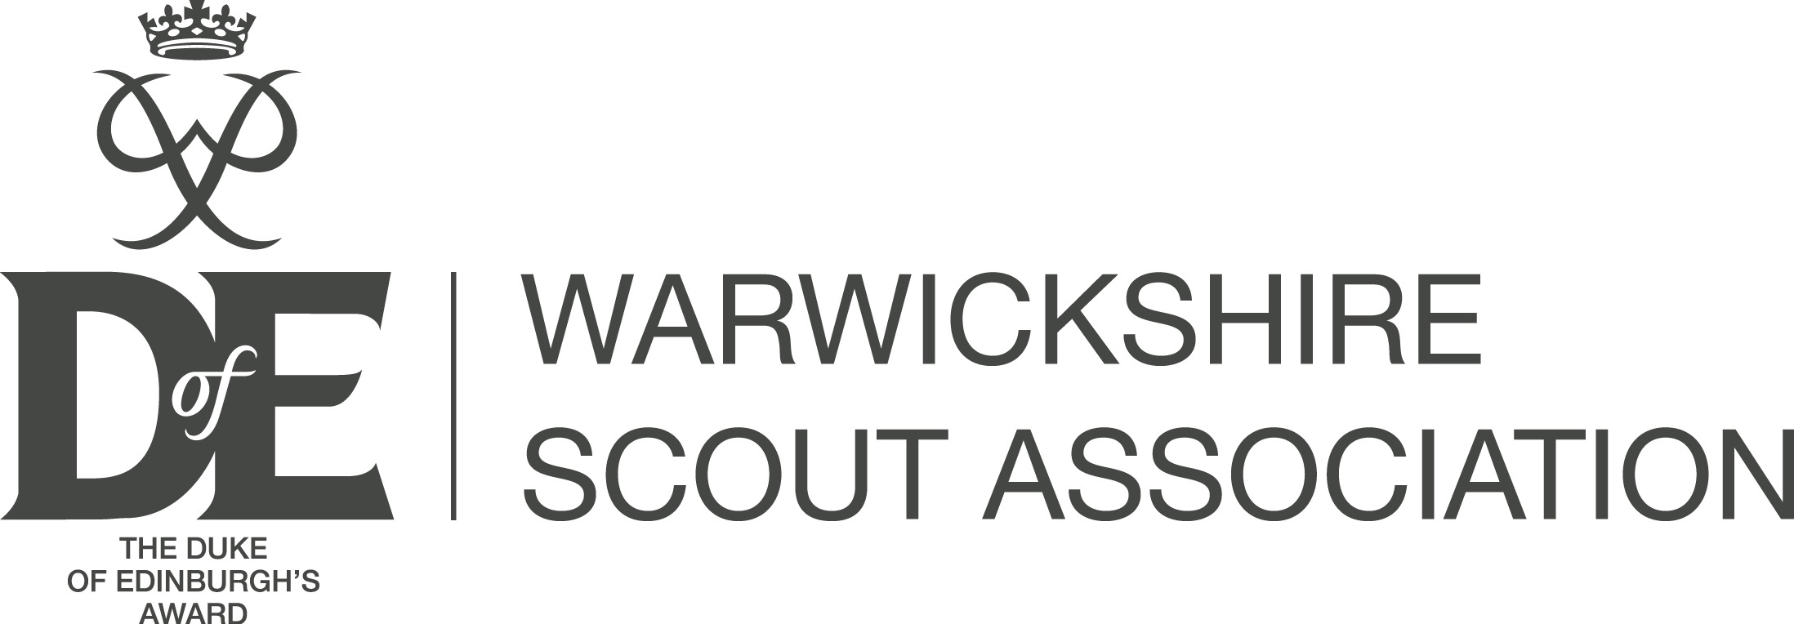
DofE Participant Enrolment Form

Please print clearly in CAPITALS or type your details in.

DofE Centre and group details (if you know them):
Explorer/ Network Unit and District: Ballers Hartshill Explorers | Leader’s name:

DofE level:
Bronze (£30.50) □ Silver (£30.50) □ Gold (£37.50) X
Have you registered for any previous levels of the DofE? No Yes
If YES – name of the DofE Centre you were registered at: Hartshill eDofE ID number : 2780887

Personal details:
First name: Corey | Last name: Charteris
Date of Birth: 07 /12 /2008 | Age: 16

Contact details:
Email address: jo.charteris@gmail.com
Address: 57 Chaytor Drive, Nuneaton, Warwickshire, CV10 9SU
Telephone contact: 07789198572

Declaration:
I agree to enrol as a participant on a DofE programme. I understand that I will be managing my programme using the online eDofE system. I acknowledge that this system has a set of terms and conditions that I agree to. These terms and conditions are available at www.edofe.org

Print Name | Signature | Date
COREY CHARTERIS | CJ Charteris | 05/06/2025

Consent to enrol from parent or guardian (if applicant is under 18 years old).
I agree to my son / daughter / ward doing a DofE programme. I note that it is my responsibility to check that any activity my son / daughter / ward undertakes for their DofE programme is appropriately managed and insured, unless the activity is directly managed or organised by their DofE group, centre or Licensed Organisation.

Print Name | Signature | Date
Joanne Charteris | JM Charteris | 05/06/2025

Note:
Data supplied on this form and in eDofE and information about DofE activities recorded in eDofE will be used by the DofE Charity, the Licensed Organisation and DofE centre to monitor and manage DofE participation and progress by young people and manage and support Leaders.

The DofE Charity will use personal data to communicate useful and relevant information to either help participants complete a DofE programme, Leaders/LOs to run DofE programmes more effectively or help the DofE Charity to improve the quality and breadth of its programmes.

Occasionally the DofE Charity may send you information relating to commercial offers. If you do not wish to receive commercial information from the DofE Charity you can choose not to by amending your contact preferences in your eDofE profile at any time.

Please return to Amy Fennell, 148 Bucks Hill, Nuneaton, Warwickshire, CV10 9LH or
Email: dofe@warwickshirescouts.org.uk

Please make payment for enrolment via Bank transfer: In the reference field please put "DOFE" plus name of participant.
Warwickshire Scout Council, Sort Code 40 52 40, Account Number 00018107

